Story telling with data

* **The importance of context**
  + Who is your audience?
  + What do you need them to know or do?
* **Choosing an effective visual**
  + What is the best way to show the data you want to communicate?
  + e.g. simple text, table, heatmap, line graph, slopegraph, bar chart, stacked bar chart, waterfall chart, square area graph, pie donut charts, …
* **Clutter is your enemy**
  + Gestalt Principles of Visual Perception.
  + Alignment, strategic use of white space, and contrast.
* **Focus your audience’s attention**
  + Frame up the importance of preattentive attributes (e.g. size, color, position).
  + Create a visual hierarchy of components.
  + Color as a strategic tool is covered in depth.
* **Think like a designer**
  + Do with the data (function) and create a visualization (form).
* **Dissecting model visual**
  + Five exemplary visuals and discuss specific thought process and design choice.
  + What and how to emphasize and de-emphasize through use of color, thickness of lines, and relative size.
  + Effective use of words to title, label, and annotation.
  + Alignment and positioning of components within the visuals.
* **Lessons in storytelling**
  + Clear beginning, middle, and end.
  + Power of repetition, narrative flow, considerations with spoken and written narratives, and various tactics to ensure our story comes across clearly.

The Importance of Context

Exploratory and Explanatory Analysis (Focus on explanatory analysis).

1. To **whom** are you communicating?

* Avoid general audience (e.g. anyone who might be interested)
* Resonate with your audience and form a communication that will meet their needs.
* Do audience already trust you as an expert? Do you need to establish credibility?

1. **What** do you want your audience to know or do?

* Concisely articulate what you want your audience to know.
* Do not use your slides as your teleprompter.

1. **How** can you use data to help make your point?

3-minute Story and Big Idea

* 3-minute Story
  + If you have only three minutes to tell your audience what they need to know, what would you say?
* Big Idea
  + It must articulate your unique point of view.
  + It must convey what’s at stake.
  + It must be a complete sentence.

Choosing an effective visual

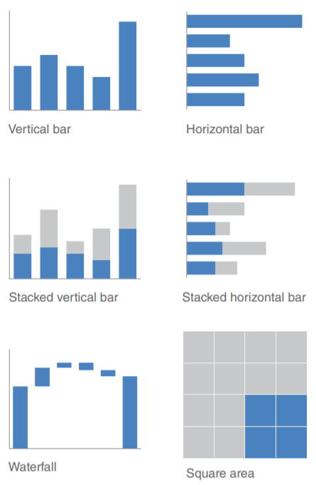

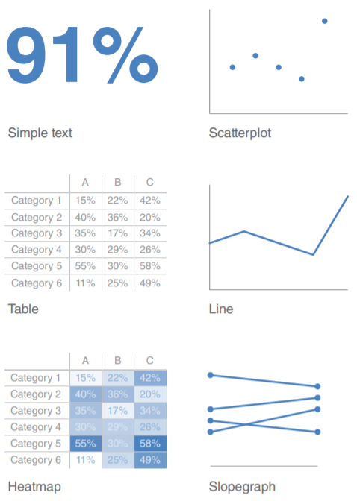

To be avoided: pie charts, donut charts, 3D, and secondary y-axes.

Clutter is your enemy

Cognitive Load: how hard audiences believe they are going to have to work to get the information out of your communication.

Gestalt Principles of Visual Perception: proximity, similarity, enclosure, closure, continuity, and connection

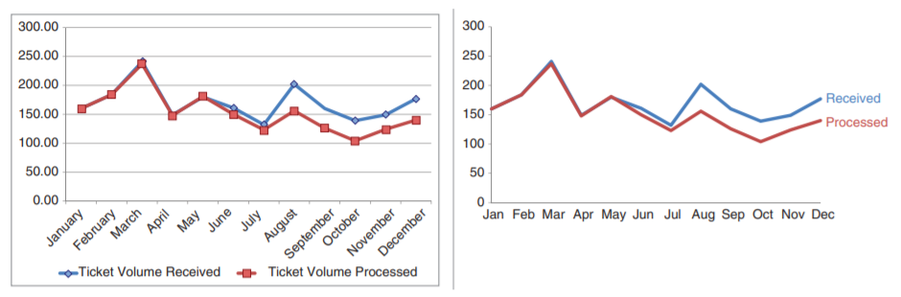

Focus your audience’s attention

Preattentive attributes: size, color, and position on page.

Three types of memory: iconic memory, short-term memory, long-term memory

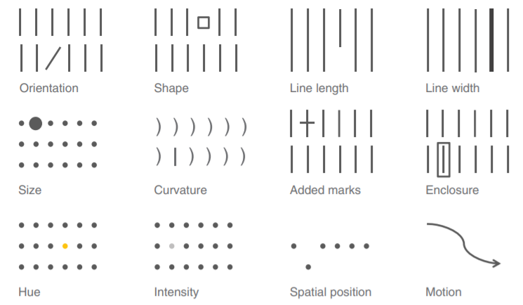

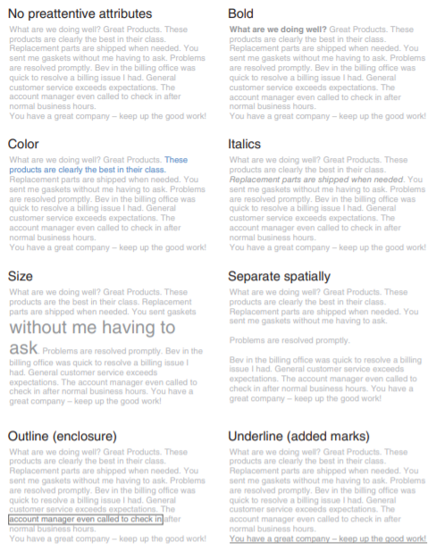

Think like a designer

Affordance

Make it obvious how product is to be used.

Leverage visual affordances to indicate to our audience how to use and interact with our visualizations.

Highlight the important stuff. (e.g. bold, color, size)

Eliminate distractions.

Not all data are equally important.

When detail isn’t needed, summarize.

Ask yourself: would eliminating this change anything?

Push necessary, but non-message-impacting items to the background.

Create a clear hierarchy of information.

Accessibility

Don’t overcomplicate. (If it’s hard to read, it’s hard to do.)

Make it legible.

Keep it clean.

Use straightforward language.

Remove unnecessary complexity.

Text is your friend. (e.g. label, explain, reinforce, highlight, recommend)

Aesthetics

Be smart with color.

Pay attention to alignment.

Leverage white space.